Columbia Asia Hospital Analysis
Objective Question
Q1. In analysing the hospital dataset with Power BI, ensure data cleaning to address inconsistencies and missing values before further analysis.
Ans. Data cleaning steps in Power BI
- Load the Data
  - Added two files: Doctors_Patient_Data and Hospitals Data into Power BI.
- Open Power Query Editor
  - Clicked Transform Data to start cleaning and editing the data.
- Check for Missing Values
  - Looked through all columns to see if any values were missing.
  - Found missing values in the pat_score column.
- Fix Missing Data
  - Replaced the empty values in pat_score with 0 to keep the data consistent.
- Check Formatting
  - Made sure names and text were neat (same style, no extra spaces).
  - Confirmed that dates and times were in the right format.
- Check Data Types
  - Verified that numbers, text, and dates were stored in the correct format.
- Save Changes
- Clicked Close & Apply to save all the cleaning work and reload the cleaned data into Power BI.

Q2. Assess the Average Waiting Time: Analyse the patient wait times to identify the average duration a patient spends before receiving care.
Ans. Approach :
Calculate Average Waiting Time using Dax formula :
average_wait_time = AVERAGE('Hospital ER (1)'[patient_waittime])
Created a clustered column and line chart showing:
- Count of Doctor ID (by department) as columns.
- Average patient wait time as a line.
This helped compare how the number of doctors in each department relates to patient wait times.
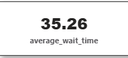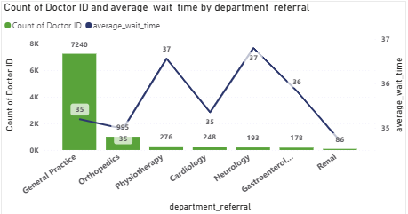

Insights
- General Practice is heavily staffed but still has long wait times
→ 7,240 doctors, yet wait time is 35 minutes—suggests high patient load or inefficiencies.
- Specialty departments are under-resourced
→ Departments like Renal (86 doctors) and Neurology (193) have very few doctors but wait times are still 37 minutes.
- Wait time remains high across all departments
→ Despite big differences in doctor count, wait times range narrowly from 35 to 37 minutes—indicating systemic issues beyond staffing.
- Physiotherapy and Renal face the worst delays
→ Both have the highest wait time (37 mins) and lowest doctor
Q3.Visits by Department Referral: Calculate the total number of visits to each department based on referrals to understand which departments are most frequently visited.
Ans. Approach
Create a Dax Measure to calculate total number of visits:
TotalVisits = COUNTROWS('Hospital ER (1)')
To visualize the visits by Departmental Referral we have to create a bar chart and a card for better visual context.
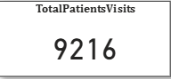
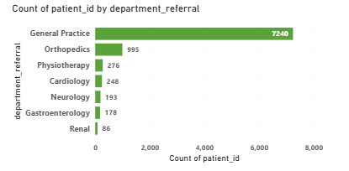
Insights:
The hospital recorded a total of 9,216 visits across all departments.
- General Practice has the highest number of visits (7,240), indicating it handles the majority of patient referrals.
- Orthopaedics follows with 995 visits, while other departments like Physiotherapy, Cardiology, and Neurology have much fewer.
- This shows a high dependency on General Practice, suggesting an uneven distribution of patients across departments.
Q4.Patient Visits by Age Group: Segregate patient visits according to different age groups to see which demographics utilize healthcare services the most.
Ans. Approach
Create a calculated column (Age Group) using Switch statement to split into age category and used a column chart to visualize the data.
AgeGroup = SWITCH(TRUE,'Hospital ER (1)'[patient_age] < 18,"0-17",
'Hospital ER (1)'[patient_age] < 29,"18-28",
'Hospital ER (1)'[patient_age] < 40,"29-39",
'Hospital ER (1)'[patient_age] < 60, "40-59",
'Hospital ER (1)'[patient_age] < 70, "60-69",
'Hospital ER (1)'[patient_age] >=70, "70+")
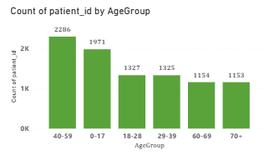
Insights:
The 40–59 age group recorded the highest number of visits (2,286), indicating that middle-aged patients use healthcare services the most.
The 0–17 age group ranks second with 1,971 visits, showing high hospital usage among children and teenagers.
The 18–39 age groups show moderate visit counts, while 60+ groups have slightly lower visits.
Overall, middle-aged and young patients are the key demographic segments driving hospital visits.

Q5.Were there any Null values in the data? What would be the best way to handle these Null values and which approach have you opted for?
Ans.
Findings
- Most columns had no missing values.
- The patient_sat_Score (Customer Satisfaction) column had a lot of missing data (72%).
- This column is important because it shows patient feedback and helps improve services.
Approach Taken
- Since so many values were missing in patient_sat_Score, using averages (mean/median) could give wrong results.
- To keep things simple and fair, I replaced all missing values with 0 so the dataset stays consistent.
General Strategy for Handling Missing Data
- First, check how important the column is for analysis.
- Depending on its importance:
  - Use 0 or “Not Available” for less important columns.
  - Use statistical methods (mean, median, mode) for numeric columns when suitable.
- Always make sure the method chosen does not change or bias the dataset.
Q6.Is there any relation between the number of visits and the Gender of the patients?
Ans. Approach
- Built a Doughnut Chart to show the total visits split by patient gender.
- Set Patient_Gender as the legend and used the count of Patient_ID to represent total visits.
- This chart gives a clear picture of which gender group accounts for more hospital visits, though it doesn’t necessarily indicate a direct relationship.
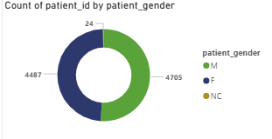
Insights:
Male patients account for the highest number of visits (4,705), slightly more than female patients (4,487).
- A very small portion (24) is marked as Not Classified, indicating minimal missing or undefined gender data.
- The gender distribution is fairly balanced, suggesting healthcare services are accessed almost equally by both genders.
- This breakdown helps in understanding patient demographics and planning gender-sensitive healthcare strategies.
Q7.Average Satisfaction by Demographics: Determine the relationship between patient satisfaction scores, their age groups, and racial backgrounds to pinpoint areas for improvement in patient experience.
Ans. Approach
Made a bar chart to see how patient satisfaction changes across different age groups and races.
- Set up the chart like this:
  - X-axis: Average satisfaction score (PatientSatScore)
  - Y-axis: Age groups
  - Legend: Patient race
- This chart helps us compare satisfaction levels among different demographic groups.
Note: The satisfaction score column has about 72% missing values, so the insights may not be fully reliable.
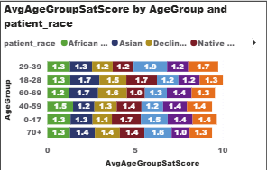
Insights:
The average satisfaction scores are almost the same across different age groups and races, with very little difference.
Some groups in the 18–28 and 40–59 age ranges show slightly higher satisfaction.
Since about 72% of the satisfaction data is missing, these results may not truly reflect patient experience.
To get more reliable insights, the hospital should collect better feedback and encourage more patients to share their ratings.

Q8.The hospital's managing director seeks to evaluate the revenue of each department to understand how much revenue is generated by each.
Ans. Approach
Created a Dax measure to calculate the total revenue by each department:
TotalRevenue = SUM(Sheet1[Total Bill])
and also create a bar chart to visualise revenue distribution across each department.
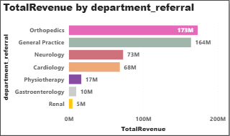
Insights:
The Orthopedics department leads in revenue with ₹173M, closely followed by General Practice at ₹164M.
- Neurology (₹73M) and Cardiology (₹68M) show moderate contributions to overall earnings.
- Departments like Physiotherapy, Gastroenterology, and Renal generate significantly lower revenue.
- These results highlight Orthopedics and General Practice as the hospital’s top-performing areas, reflecting strong patient demand and high service usage
Q9. Which department is charging the highest appointment fees in general? Use an aggregation DAX function to solve this question.
Ans. Approach
• First, I created a DAX measure to find the highest appointment fee using an aggregation function:
HighestAppointmentFees = MAX(Sheet1[Appointment Fees])
• Then, I built another DAX measure to identify which department that fee belongs to:
DepartmentWithHighestFee =
VAR MaxFee = [HighestAppointmentFees]
RETURN
CALCULATE(
SELECTEDVALUE(Sheet1[Department_Referral]),
Sheet1[Appointment Fees] = MaxFee
)
Together, these measures show both the maximum fee and the department charging it.
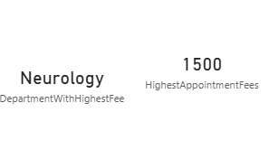

Insights
- The Neurology department has the highest appointment fee at $1,500.
- This suggests that Neurology likely handles more specialized or complex
- consultations, which explains the higher charges compared to other departments.

Q10. Create a tabular visualization in the Report view which consists of Month-wise total visits in the hospital. Add a third column in the table that consists of the previous month’s total visits for each month’s row. Also, include a column that states whether the visits in a month are greater than that of the previous month's visits.
Ans. Approach
To analyse month-over-month trends in patient visits, I have created a following DAX measures:
TotalVisits = COUNTROWS('Hospital ER (1)')
and create another DAX measure named with last_month_visit to compare current month from the previous month.
LastMonthVisits =
VAR CurrentMonth =
MAX ('Hospital ER (1)'[MonthNumber] )
RETURN
CALCULATE (
[TotalVisits],
FILTER (
ALL ( 'Hospital ER (1)' ),
'Hospital ER (1)'[MonthNumber] = CurrentMonth - 1
)
)
and create a column named with Increase compared to previous to compare with previous and current month and gives the values in Yes and No.
IncreaseComparedToPrevious = IF([TotalVisits] > [LastMonthVisits],"Yes","No")
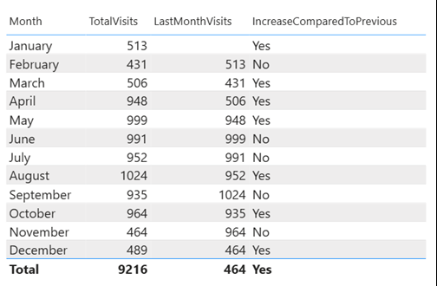

Insights:
- The hospital recorded fluctuating visit patterns throughout the year.
- January → February saw a slight drop, indicating possibly seasonal or post-holiday effects.
- A steady rise was observed from March to May, with the highest month being May (999 visits) showing strong patient inflow during mid-year.
- After May, a small decline appeared in June and July, before rebounding in August, which again shows increased visits (1,024) possibly due to seasonal ailments or specific health campaigns.
- The lowest patient turnout occurred in November (464), suggesting reduced hospital activity towards the year-end.
- Overall, the pattern alternates between increases and drops, suggesting a cyclic or seasonal visit behavior that could help in resource and staffing optimization.
Q11. Using ‘Calculate’ and a row iteration DAX function calculate the total number of patients who have visited Dr. Smith.
Ans. Approach
- To determine how many patient’s visited Dr. Smith a calculate function used along with a row level filter.
DrSmithsTotalVisitPatients = CALCULATE(COUNTA(Sheet1[patient_id]),
Sheet1[Doctor Name] = "Dr. Smith")
- The CALCULATE function changes the filter context to include only those rows where the doctor’s name is “Dr. Smith”, and the COUNTA function counts all unique patient visit entries for that doctor.
- Finally, the measure was displayed using a card visualization to show the total number of visits made to Dr. Smith.
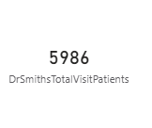

Insights:
- Dr. Smith recorded a total of 5,986 patient visits, indicating a high patient engagement and trust level compared to other doctors.
- This may reflect Dr. Smith’s specialization, experience, or popularity within the hospital.
- The insight can help hospital management in workload distribution or resource planning, ensuring that doctors with higher visit counts are provided additional support or scheduling adjustments.
Q12. Calculate the average age of the patients who visit the Orthopedics department. Will the approach used to calculate this metric be different if the requirement had been all departments’ average age?

Ans. Approach
- To calculate the average age of patients in the Orthopaedics department, a DAX measure was created specifically for that department:
OrthopaedicsAvgAge = CALCULATE(AVERAGE('Hospital ER (1)'[patient_age]),'Hospital ER (1)'[department_referral] = "Orthopaedics")
- If we want to calculate the average age across all departments, the approach changes by using the ALL() function in DAX, which removes filters and calculates the overall average age.
- The measure was modified to ignore any department filters to calculate the average age across all departments:
OverallDeptAvgAge = CALCULATE(AVERAGE('Hospital ER (1)'[patient_age]),ALL('Hospital ER (1)'))

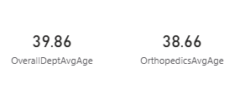

Insights
- The average patient age in the Orthopedics department is 38.66 years, while the overall hospital average is 39.86 years.
- Orthopedic patients are slightly younger than the overall patient population, suggesting that middle-aged adults are more prone to bone, joint, or injury-related issues.
- This insight helps management in resource planning and specialized care programs for this specific age group.

Q13 Were there any data format issues in the data, and if there were/are how you handle them?

Ans. Approach
If the dataset had any data format problems like wrong date/time formats, currency mismatches, or inconsistent text capitalization, I fixed them before analysis to keep data clean and accurate.
For example:
- If dates were in different formats, I changed them to a standard Date/Time type using Power Query’s "Change Type" or DAX functions like DATEVALUE() or FORMAT().
- If currency or numbers were inconsistent, I set their data type to Decimal or Whole Number and adjusted formatting.
- For text issues, I used functions like UPPER(), LOWER(), or PROPER() to make text consistent.
- If there were blank or null values from format problems, I replaced or filtered them using Power Query’s "Replace Values" or DAX logic like IF(ISBLANK(), ...).
This cleaning step made sure the data was uniform and ready for reliable analysis without errors or conflicts.
Q14. When we add a column in Power Query what’s the code that comes in M language in the formula bar? What do you know about M-query?

Ans. When we add a new column in Power Query, the M language code that appears in the formula bar generally starts with Table.AddColumn.
For example:
= Table.AddColumn(#"Previous Step", "New Column Name", each [ExistingColumn] * 2)
This line means a new column is being added to the table based on a logic or expression provided after each.
M language, also known as Power Query Formula Language, is the scripting language behind Power Query.
It is used to perform data transformation, cleaning, and preparation before loading the data into Power BI.
M is a case-sensitive, functional language designed to work with data tables — it executes step by step (each step feeding the next).
Some key points about M-query:
- It is used in the Power Query Editor.
- Each transformation in Power Query creates a new step written in M.
- You can view or edit these steps in the Advanced Editor.
- Common functions include Table.AddColumn, Table.TransformColumnTypes, Table.RenameColumns, and Table.SelectRows.
Q15. Identify the top 5 doctors who generated the most revenue but had the fewest patients. (SQL).
Ans. Approach
- Join tables → Combine doctor and hospital data using the patient ID (so we get doctor name + bill amount together).
- Group by doctor → Collect all patients for each doctor.
  - Add up all bills → SUM(total_bill) = total revenue.
  - Count patients → COUNT(DISTINCT patient_id) = patient count.
- Sort results →
  - First by revenue (highest first).
  - Then by patient count (lowest first).
- Pick top 5 → Use LIMIT 5 to show only 5 doctors.
Query:
SELECT
d.doctor_name,
SUM(h.total_bill) AS total_revenue,
COUNT(DISTINCT d.patient_id) AS patient_count
FROM doctor_patients_data d
INNER JOIN hospital_er h
ON d.patient_id = h.patient_id
GROUP BY d.doctor_name
ORDER BY total_revenue DESC, patient_count ASC
LIMIT 5;
Output:
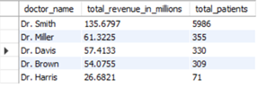

Insights:
- Dr. Smith generated the highest total revenue (₹135.67M) with 5,986 patients, indicating strong patient inflow and consistent revenue generation.
- Dr. Miller and Dr. Davis followed with ₹61.32M and ₹57.41M revenue respectively, but with significantly fewer patients (355 and 330) suggesting higher consultation or treatment charges.
- Dr. Brown also showed similar trends, maintaining ₹54.07M revenue with 309 patients.
- Dr. Harris, though having the fewest patients (71), still contributed ₹26.68M, showing high revenue per patient possibly due to specialized or high-cost treatments.
Q16. Find the department where the average waiting time has decreased over three consecutive months. (SQL)

Ans. Approach
- Calculated the average waiting time for each department by month using the AVG() and GROUP BY functions.
- Used window function LAG() to fetch the waiting time of the previous two months for every department.
- Applied a filter condition where the current month’s average waiting time was less than both previous months, indicating a consistent decrease.
- Displayed only the distinct department names that met this trend of decreasing wait times.
Query:
SELECT DISTINCT department_referral
FROM (
SELECT
department_referral,
EXTRACT(MONTH FROM date) AS month_num,
AVG(patient_waittime) AS current_month_avg_time,
LAG(AVG(patient_waittime), 1) OVER(PARTITION BY department_referral ORDER BY EXTRACT(MONTH FROM date)) AS prev_month_avg_time,
LAG(AVG(patient_waittime), 2) OVER(PARTITION BY department_referral ORDER BY EXTRACT(MONTH FROM date)) AS prev_2month_avg_time
FROM hospital_er
GROUP BY department_referral, EXTRACT(MONTH FROM date)
) AS wait_analysis
WHERE current_month_avg_time > prev_month_avg_time
AND prev_month_avg_time > prev_2month_avg_time;
Output:
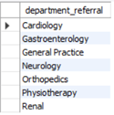
Insights:
- Departments such as Cardiology, Orthopedics, and Renal consistently reduced their average patient waiting time over three consecutive months.
- This indicates improved operational efficiency, better patient flow management, and possibly optimized scheduling or staffing strategies during those months.
Q17. Determine the ratio of male to female patients for each doctor and rank the doctors based on this ratio. (SQL)
Ans. Approach
- Count male patients per doctor
  - Use COUNT() with WHERE patient_gender = 'M'
  - Group by doctor_name
- Count female patients per doctor
  - Use COUNT() with WHERE patient_gender = 'F'
  - Group by doctor_name
- Join both counts
  - Match male and female counts using JOIN ON doctor_name
- Calculate ratio and rank
- Use ROUND(male / female, 2) for ratio
- Use RANK() to rank doctors by highest ratio
Query:
WITH male_cte AS (
SELECT dp.doctor_name, COUNT(hr.patient_gender) AS male_patient_count
FROM hospital hr
JOIN doctor_patient dp ON hr.patient_id = dp.patient_id
WHERE hr.patient_gender = 'M'
GROUP BY dp.doctor_name
),
female_cte AS (
SELECT dp.doctor_name, COUNT(hr.patient_gender) AS female_patient_count
FROM hospital hr
JOIN doctor_patient dp ON hr.patient_id = dp.patient_id
WHERE hr.patient_gender = 'F'
GROUP BY dp.doctor_name
)
SELECT
m.doctor_name,
m.male_patient_count,
f.female_patient_count,
ROUND(1.0 * m.male_patient_count / f.female_patient_count, 2) AS male_female_ratio,
RANK() OVER (ORDER BY 1.0 * m.male_patient_count / f.female_patient_count DESC) AS ratio_rank
FROM male_cte m
JOIN female_cte f ON m.doctor_name = f.doctor_name;
Output:
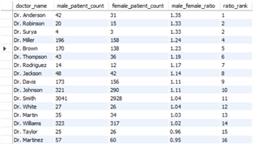
Insights:
Top-ranked doctors treat significantly more male patients:
- Dr. Anderson (Rank 1) has a male-to-female ratio of 1.35, meaning he treats 35% more males than females.
- Dr. Robinson and Dr. Surya follow closely with ratios of 1.33 and 1.31, showing a similar trend.
High-volume doctors show balanced gender distribution:
- Dr. Smith treated over 6,000 patients (3,041 males, 2,986 females) with a ratio of 1.04, indicating a nearly equal gender split.
- Dr. Johnson and Dr. Davis also handled large patient volumes with ratios around 1.11, suggesting slight male dominance but overall balance.
Lower-ranked doctors treat more females:
- Dr. Taylor (Rank 15) has a ratio of 0.92, meaning more female patients than male.
- Dr. Martinez also shows a female-leaning distribution with a ratio of 0.95.
Q18. Calculate the average satisfaction score of patients for each doctor based on their visits. (SQL)

Ans. Approach:
- Joined the tables:
  - Combined hospital_er and doctor_patients_data using patient_id to align each patient’s satisfaction score with their respective doctor.
- Count and aggregate:
  - Used COUNT(DISTINCT hr.patient_id) to get unique patient visits per doctor.
  - Calculated the average satisfaction score with AVG(COALESCE(hr.patient_sat_score, 0)) ensuring null scores are treated as zero to prevent skewed averages.
- Group by doctor:
  - Applied GROUP BY dp.doctor_name to compute these metrics at the doctor level.
Query:
SELECT
dp.doctor_name,
COUNT(DISTINCT hr.patient_id) AS patient_visits,
AVG(COALESCE(hr.patient_sat_score, 0)) AS avg_sat_score
FROM hospital_er hr
JOIN doctor_patients_data dp ON hr.patient_id = dp.patient_id
GROUP BY dp.doctor_name;
Output:
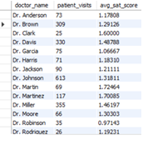
Insights:
- Dr. Surya (3.43) and Dr. Taylor (2.37) achieved the highest satisfaction averages, showing excellent patient experience.
- Dr. Wilson (1.77), Dr. Martin (1.72), and Dr. Martinez (1.70) also demonstrate strong satisfaction levels.
- High-volume doctors like Dr. Smith (5,986 visits) and Dr. Johnson (613 visits) maintain consistent satisfaction (~1.3), reflecting stable performance across a large patient base.
- Dr. Robinson (0.97) and Dr. Garcia (1.07) have lower satisfaction scores, which may indicate service quality issues or gaps in patient expectations.
- Overall trend: Satisfaction varies widely across doctors, suggesting opportunities to learn best practices from top-rated doctors and improve consistency across departments.
Q19. Find doctors who have treated patients from different races and calculate the diversity of their patient base. (SQL)

Ans. Approach:
- Join the datasets:
  - Used an INNER JOIN between doctor_patients_data and hospital_er on patient_id to connect each doctor with their patients’ demographic details.
- Calculate unique races per doctor:
  - COUNT(DISTINCT hr.patient_race) finds how many different races each doctor has treated.
- Compare against total diversity:
  - Divided by the total number of distinct races in the hospital (from a subquery: SELECT COUNT(DISTINCT patient_race) FROM hospital_er).
  - Multiplied by 100 to express it as a percentage diversity score.
- Group by doctor:
  - Aggregated results at the doctor level using GROUP BY dp.doctor_name.
Query:
SELECT dp.doctor_name,
ROUND(COUNT(DISTINCT hr.patient_race) * 100.0 /
(SELECT COUNT(DISTINCT patient_race) FROM hospital_er)
) AS diversity_of_doctors_patient_race
FROM doctor_patients_data dp
INNER JOIN hospital_er hr
ON dp.patient_id = hr.patient_id
GROUP BY dp.doctor_name;
Output:
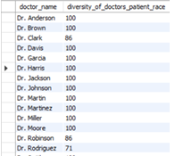
Insights:
- Most doctors (Dr. Smith, Dr. Johnson, Dr. Miller, Dr. Brown) achieved a 100% diversity score, meaning they treated patients from all racial groups — showing broad and inclusive engagement.
- Some doctors (Dr. Robinson – 86%, Dr. Rodriguez – 71%, Dr. Surya – 57%) show lower diversity, which may be due to specialization, location bias, or demographic concentration.
- Overall trend: Most doctors serve diverse populations, which is a strong indicator of inclusivity and equal access to care.
- Next step: Further analysis could check if higher diversity links to higher satisfaction or revenue, giving deeper business insights.

Q20. Calculate the ratio of total bills generated by male patients to female patients for each department. (SQL)
Ans. Approach
- Join tables
  - Connect doctor_patients_data (doctor info) with hospital_er (patient info) using patient_id.
- Count distinct patient races per doctor
  - Use COUNT(DISTINCT hr.patient_race) to find how many different races each doctor has treated.
- Find total distinct races in hospital
  - Use a subquery (SELECT COUNT(DISTINCT patient_race) FROM hospital_er) to get the total number of racial groups present.
- Calculate diversity percentage
  - Divide each doctor’s distinct race count by the hospital’s total race count.
  - Multiply by 100 to convert into a percentage.
  - Use ROUND() for cleaner results.
- Group by doctor
Ensure results are shown per doctor using GROUP BY dp.doctor_name.
Query:
SELECT
dp.doctor_name,
ROUND(
COUNT(DISTINCT hr.patient_race) * 100.0 /
(SELECT COUNT(DISTINCT patient_race) FROM hospital_er), 2
) AS diversity_of_doctors_patient_race
FROM doctor_patients_data dp
INNER JOIN hospital_er hr
ON dp.patient_id = hr.patient_id
GROUP BY dp.doctor_name;
Output:
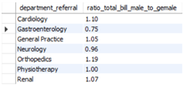
Insights:
- Orthopaedics (1.19) and Cardiology (1.10) → Male patients generate more revenue, likely due to frequent or costlier treatments.
- General Practice (1.05) and Renal (1.07) → Spending is almost equal between male and female patients.
- Gastroenterology (0.75) → Female patients contribute more billing, showing women may seek or require care more in this department.
- Physiotherapy (1.00) → Balanced ratio, meaning both genders spend equally.
- Overall → Gender differences affect departmental revenue, which is useful for targeted outreach and service planning.
Q21. Update the patient satisfaction score for all patients who visited the "General Practice" department and had a waiting time of more than 30 minutes. Increase their satisfaction score by 2 points, but ensure that the satisfaction score does not exceed 10. (SQL)

Ans. Approach
- Created a new column instead of overwriting the original data for maintaining data integrity and easy comparison.
- Then applied a conditional update that targets only patients under General Practice with waiting time > 30 mins, ensuring focused modification.
- The use of COALESCE handled null satisfaction scores gracefully, while LEAST prevented scores from exceeding 10.
Query:
ALTER TABLE hospital_er
ADD COLUMN updated_sat_score DECIMAL(5,2);

UPDATE hospital_er
SET updated_sat_score =
CASE
WHEN LOWER(department_referral) = 'general practice' AND patient_waittime > 30
THEN LEAST(COALESCE(patient_sat_score, 0) + 2, 10)
ELSE COALESCE(patient_sat_score, 0)
END;

SELECT
department_referral,
patient_waittime,
COALESCE(patient_sat_score, 0) AS old_sat_score,
updated_sat_score
FROM hospital_er
WHERE department_referral = 'General Practice';

Output:
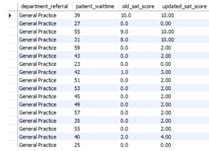

Subjective Question
Q1. What is the relation between patient wait time and satisfaction scores?
Ans. Approach
Create a calculated measure for average satisfaction score:
avg_sat_score = AVERAGE('Hospital ER (1)'[patient_sat_score])
and used a scatter chart to visualise the relationship between patient wait time and average satisfaction score.
Note: 72% of satisfaction score values were null, which were replaced with 0 before visualization this data treatment may have influenced the trend slightly.
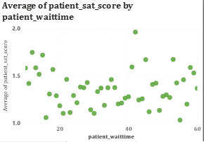
Insights:
- Wait time directly impacts satisfaction: Shorter waits (0–20 minutes) lead to higher satisfaction scores, while longer waits steadily reduce patient happiness.
- Extended delays cause dissatisfaction: Beyond 30 minutes, satisfaction drops close to 1.0, showing frustration with long waiting periods.
- Operational takeaway: Hospitals should focus on reducing wait times to improve patient experience, feedback scores, and overall service quality.
Recommendation:
- Reduce patient wait times through better scheduling and queue management.
- Improve communication to set realistic wait-time expectations.
- Reassess missing data: If feasible, collect or estimate satisfaction feedback rather than defaulting to zero to improve accuracy.
- Drill down by department to see where this relationship is strongest.

Q2. How do patient demographics affect the frequency of visits to different departments?
Ans. Approach
  - Created a column and line combo chart in Power BI.
  - X-axis: department_referral (department names).
  - Y-axis (Column): Count of patient_id to represent visit frequency.
  - Legend: AgeGroup to show demographic distribution across departments.
  - Y-axis (Line): Sum of Total Bill to visualize spending trends alongside visit frequency.
  - Chose to exclude gender from this view since it had minimal impact on visit patterns compared to age segmentation.
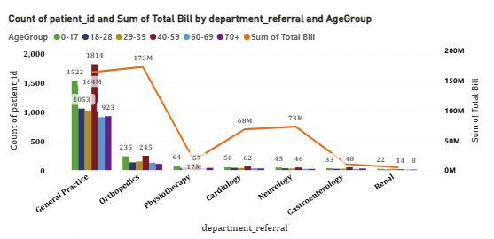
Insights:
- The "Front Door" Effect: General Practice is the primary entry point for care, driving the highest patient volume across every age group—especially adults aged 29–69.
- Age Drives Orthopaedics: Demand for Orthopaedics spikes significantly in older adults (40–69), directly reflecting the rise of age-related bone and joint issues.
- High Value vs. High Volume: While Cardiology and Neurology see fewer patients, they generate much higher costs, driven by the complexity of specialized treatment.
- The Demographic Shift: Usage shifts clearly by age: younger patients (0–28) rely almost exclusively on General Practice, while elderly patients drive the demand for specialists.

Recommendations
- Staff Where the Demand Is: Prioritize staffing and resource allocation in General Practice and Orthopaedics to prevent bottlenecks in these high-traffic areas.
- Target Prevention: Launch age-specific wellness initiatives—such as mid-life checkups (40–59) and senior mobility programs—to catch issues before they become acute.
- Audit High-Cost Areas: Scrutinize cost efficiency in "low volume, high cost" departments like Neurology to ensure expensive treatments remain financially sustainable.
- Deepen the Data: Don't stop at age. Integrate gender and demographic data into future analyses to uncover hidden trends that current metrics might miss.
Q3. Is there a noticeable trend in the volume of patient visits throughout the year?
Ans. Approach
• Created a column and line combo chart in Power BI to observe patient visit trends over time.
• X-axis: Month (with Year included for a continuous time series).
• Y-axis (Column): Measure TotalVisits representing the total number of patient visits each month.
• Y-axis (Line): Same measure TotalVisits to show the overall trend across months and years.
• Time-based data was sorted chronologically to ensure trend clarity.
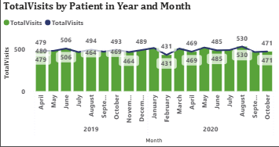
Insights
• Patient visits fluctuate moderately throughout the year with no extreme seasonal spikes.
• A slight dip in February is observed in both years possibly due to fewer working days or seasonal patterns. • The highest visits occurred in August 2020 (530 visits), indicating a mid-year peak.
• Overall, average monthly visits remain consistent around 470–510, reflecting steady hospital engagement and balanced patient inflow.
• The slight rise in 2020 compared to 2019 may indicate improved outreach, awareness, or patient retention.
Recommendations
• Capacity Planning: Maintain a consistent staffing level throughout the year since visit volumes remain stable, with minor adjustments during peak months like August.
• Investigate February Dips: Review operational or external factors (e.g., holidays, weather, scheduling practices) contributing to lower visits in February.
• Enhance Seasonal Preparedness: Even with steady visits, ensure readiness for minor fluctuations in high-demand months.
• Monitor Year-on-Year Growth: Continue tracking this trend to measure growth in patient base and evaluate the impact of new hospital initiatives or campaigns.
Q4. Which age groups report the highest and lowest satisfaction scores?
Ans. Approach
Create a DAX measure named with avg_sat_score and to visualise we create a column chart by age group and also added data labels to visualise the exact data for better readability.
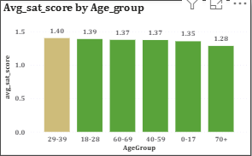
Insights:
- The 29–39 age group reports the highest average satisfaction (1.40), closely followed by 18–28 (1.39).
- Satisfaction gradually declines with increasing age, reaching the lowest average (1.28) among patients aged 70+.
- The trend suggests that younger and middle-aged patients are slightly more satisfied with their hospital experience than older ones.
- Although differences are small, the consistent downward pattern across age groups indicates an age-related perception gap in patient experience.
Recommendation:
- Introduce age-friendly services such as clearer communication, mobility support, and priority service for seniors.
- Train staff in empathetic interaction tailored to older patients’ needs
- Organize focus groups for the 60+ and 70+ age brackets.
- Identify pain points around comfort, accessibility, and staff behaviour
- Continue strategies that resonate with younger demographics, such as digital updates, app-based notifications, and shorter wait times.
- Explore gamified health engagement tools to keep younger patients involved
- Address the issue of 72% null satisfaction values currently replaced with 0.
- Improve survey design and collection efficiency to ensure averages accurately reflect patient sentiment.
- Consider digital kiosks, SMS surveys, or assisted feedback collection for seniors to reduce missing data.

Q5. Say someone outside of the hospital claims that there is racial or gender based discrimination in the hospital, how will you identify whether the claim was right or not?
Ans. To prove the claims of racial gender based discrimination in hospital I performed the three key analysis focusing on outcomes and experience metrics. To perform this analysis created three DAX measure .
- Average Wait Time:
average_wait_time = AVERAGE('Hospital ER (1)'[patient_waittime])

Visualisation: Clustered column chart
Purpose: To check if any specific race or gender group faces longer wait times before treatment, indicating possible bias in service speed.

- Admission Count:
Admission_Count = CALCULATE(COUNTROWS('Hospital ER (1)'), 'Hospital ER (1)'[patient_admin_flag] = TRUE())
Admission_Rate = DIVIDE( [Admission_Count],[TotalVisits])

Visualisation: 100% Stacked column chart
Purpose: To analyse if certain races or genders are less likely to be admitted compared to others, which could indicate bias in decision-making.

- Total Revenue & Avg. Satisfaction Score by Race & Gender:
avg_sat_score = AVERAGE('Hospital ER (1)'[patient_sat_score])
TotalRevenue = SUM(Sheet1[Total Bill])

Visualisation: Column Line Chart
Purpose: To check if billing or satisfaction levels differ across demographic groups, possibly reflecting treatment inequality.

- Total visits by race
Visualisation: Donut chart
Purpose: To understand the patient distribution by race and ensure balanced hospital accessibility.

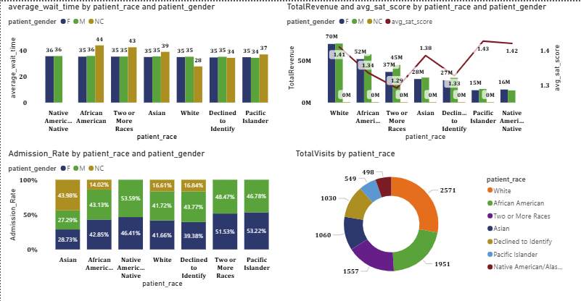
Insights:
- . Wait Time:
  - Average wait time remains consistent (34–36 minutes) across all races and genders, showing no delay bias.
- Admission Rate:
  - Admission rates are balanced between 48–53%, suggesting fair admission decisions across demographics.
- Revenue & Satisfaction:
  - Revenue and satisfaction are stable across all groups (avg. satisfaction 1.29–1.43). • Minor differences appear operational rather than discriminatory.
- Visit Distribution:
  - Majority of visits come from White (27.9%) and Asian (21.1%) groups, but all other races are reasonably represented.
  - No evidence of exclusion or service denial to any race.
- Overall:
  - No significant gender or racial discrimination observed. • Small variations are within normal operational range.
Recommendation:
- Fairness Monitoring System
Create a Demographic Equality Dashboard (Wait Time, Admission Rate, Revenue, Satisfaction by Race & Gender).
- Department-Level Audit
Conduct periodic reviews to ensure consistent triage, admission, and billing practices.
- Patient Feedback Mechanism
Collect detailed satisfaction surveys across all demographic groups to capture subtle differences.
- Bias Awareness Training
Organize diversity and sensitivity workshops to reduce unconscious bias in patient care.
- Transparent Reporting
Publish a quarterly Fairness & Inclusion Report to build trust and show accountability.
Q6. The hospital management intends to offer discounts to patients. How should these offers/discounts be assigned to patients, on what basis, and why?
Ans. Approach
Creating DAX measure named with Total Revenue, Total Visits, and Average Appointment Fees. To determine how discounts should be allocated and decided to analyse through Age group. Based on this metrics we analyse and visualise the data: to visualise the data we used charts like donut chart and bar & line chart.
DAX Measure :
TotalVisits = COUNTROWS('Hospital ER (1)')
TotalRevenue = SUM(Sheet1[Total Bill])
AvgAppointmentFees = AVERAGE(Sheet1[Appointment Fees])
Visualisation:
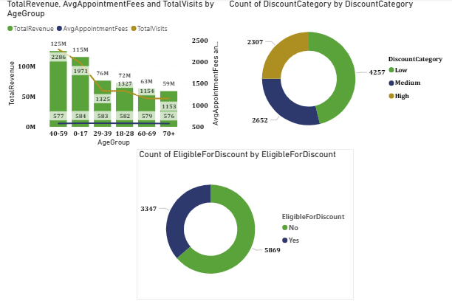
Insights:
- The age group 40-59 and 0-17 has generated the highest total revenue and had a maximum visits showing strong revenue and engagement so this category don’t get heavy discount.
- The age group 29-39 and 18-28 has generated a moderate income and engagement and so this category does not require a heavy discounts.
- The 60–69 and 70+ age groups showed lowest revenue and visits, indicating the need for higher discounts to encourage check-ups.
After visualisation and finding insights we have created two DAX column to identify which category get how much discounts and show it is eligible for discount or not:
DiscountCategory =
SWITCH(
TRUE(),
'Hospital ER (1)'[AgeGroup] IN {"40-59", "0-17"}, "Low",
'Hospital ER (1)'[AgeGroup] IN {"29-39", "18-28"}, "Medium",
'Hospital ER (1)'[AgeGroup] IN {"60-69", "70+"}, "High",
"Low"
)

EligibleForDiscount =
SWITCH(
TRUE(),
'Hospital ER (1)'[patient_sat_score] >= 5 || 'Hospital ER (1)'[patient_age] >= 60, "Yes",
"No"
)

Patients with a satisfaction score ≥ 5 or age ≥ 60 were marked as “Yes” (eligible), while others were marked as “No”. This approach helps to target elderly and highly satisfied patients, making the discount distribution more logical and data-driven.
Recommendation:
- High Discounts (15–20%): Applicable for 60–69 and 70+ age groups.
➢ Aim: Encourage elderly patients to visit more frequently for regular health checkups.
- Medium Discounts (around 10%): Applicable for 18–28 and 29–39 age groups.
➢ Aim: Motivate working-age adults to increase engagement and improve visit frequency.
- Low or No Discounts: Applicable for 0–17 and 40–59 age groups.
➢ Aim: These groups already show high revenue and visit contribution; focus on retention and satisfaction rather than new incentives.
Q7. The hospital has a budget to hire 2-3 new doctors. They have asked for your suggestions on which departments they should hire.
Ans. Approach
To identify this I have used three key metrics to analyse:
TotalRevenue, TotalVisits, Average_Wait_Time
TotalVisits = COUNTROWS('Hospital ER (1)')
TotalRevenue = SUM(Sheet1[Total Bill])
average_wait_time = AVERAGE('Hospital ER (1)'[patient_waittime])
Visualisation:
To visualise the data we use a bar chart this helped identify the which department has high wait time and high visits and have a less doctor.
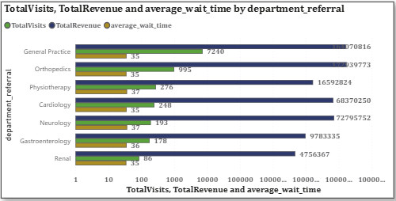
Insights:
- General Practice has the highest number of visits (7240) and high total revenue, but also a moderate wait time (35.19 mins) → indicating heavy patient load.
- Orthopaedics has high revenue but very low visits (995) → meaning fewer but possibly longer appointments or specialized treatments.
- Neurology and Cardiology show lower visits (193 & 248) but high average wait times (36.8 & 35.3 mins), suggesting doctor shortage or longer consultation durations.
- Physiotherapy and Gastroenterology have moderate wait times and medium level visits, showing manageable workloads.
- Renal department has the lowest visits (86) and lowest revenue, so it currently may not need additional doctors.
Recommendations:
- General Practice
  - Highest average wait time (7,240) despite moderate visit volume.
  - Indicates patient overload and potential understaffing.
  - Hiring more doctors can drastically reduce wait time and improve patient flow.
- Orthopaedics
  - High wait time (995) with consistent visit numbers.
  - Suggests demand exceeds current capacity.
  - Additional specialists can improve throughput and reduce delays.
- Cardiology
  - May indicate overburdened staff or missed service opportunities.
  - Hiring can help expand services and improve both care quality and revenue.
  - High visit volume (37) but relatively low revenue compared to peers.
Q8. Is the hospital profitable? How will you determine the profitability?
Ans. Approach
To analyse this I have performed two key analysis Average Revenue per Doctor and Average Revenue per Patient vs. Average Wait Time through department referral using this we create two measure :
AverageRevenueperDoctor = SUM(Sheet1[Total Bill]) / DISTINCTCOUNT(Sheet1[Doctor Name])
Avg_Bill_per_Patient = DIVIDE([TotalRevenue], DISTINCTCOUNT('Hospital ER (1)'[patient_id]))
average_wait_time = AVERAGE('Hospital ER (1)'[patient_waittime])
This analysis helps in visualise which departments generates higher revenue per doctor, helping assess productivity and efficiency and also visualise the balance between revenue efficiency, patient experience and service.
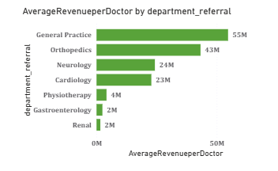
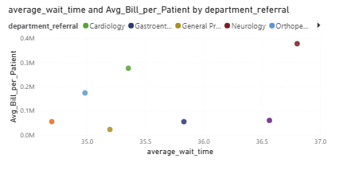
Insights:
  - General Practice and Orthopaedics show the highest revenue per doctor, indicating these departments are highly productive and financially efficient.
  - Cardiology and Neurology generate moderate revenue but might be affected by longer patient wait times.
  - Physiotherapy, Gastroenterology, and Renal have both lower revenue per doctor and per patient, suggesting lower profitability or underutilization.
  - Departments with higher average wait times tend to have higher bills per patient, which might indicate specialized or longer treatments.
Recommendation:
  - Focus investments in high-performing departments like General Practice and Orthopaedics, as they show strong profitability per doctor.
  - Improve operational efficiency in departments with long wait times (e.g., Neurology, Cardiology) to enhance both satisfaction and throughput.
  - Review underperforming departments (e.g., Physiotherapy, Gastroenterology, Renal) either by improving service offerings or optimizing staff allocation.
  - Balance profitability and patient satisfaction by ensuring that higher revenue per patient doesn’t come at the cost of excessive waiting times or poor experience.
Q9. Any Department for which the waiting time is oddly large?
Ans. Approach
To analyse this I have create a DAX measure for the average patient wait time :
average_wait_time = AVERAGE('Hospital ER (1)'[patient_waittime])
To visualise this data i used bar
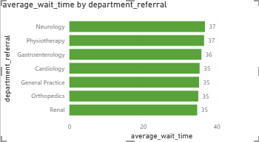
Insights:
- No department stands out with unusually high wait times — most are fairly consistent.
- However, Neurology and Physiotherapy show slightly elevated wait times (~37 minutes), hinting at potential inefficiencies in patient flow or appointment scheduling.
Recommendation:
- Assess Staffing and Scheduling
Conduct a review across all departments, especially those with high visit volumes and revenue, to ensure balanced patient distribution.
- Implement Triage and Prioritization Systems
Introduce mechanisms to differentiate urgent vs. routine cases, improving service efficiency and reducing wait times.
- Promote Digital Booking Tools
Encourage use of online appointment systems and reminder notifications to minimize missed slots and reduce crowding.

- Analyse Patient Feedback
Focus on feedback from Neurology and Physiotherapy to uncover root causes of delays — such as diagnostic bottlenecks or administrative lags.

Q10.Come up with strategies to provide discounts to the patients.
Ans. Approach
- In the earlier phase, the discount framework was built around Age Group, with categories defined by Total Revenue, Total Visits, and Average Appointment Fees.
- To broaden the scope, the analysis now examines the Patient Race dimension, aiming to identify which racial groups drive the highest visit volumes and where targeted discounts could strengthen inclusivity and engagement.
- A Power BI bar chart was developed with:
X-Axis: Total Visits Y-Axis: Patient Race
- The objective is to highlight racial groups with lower visit frequencies, where discounts or promotional offers could stimulate participation and improve healthcare accessibility.
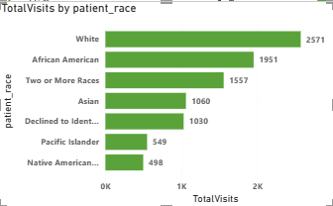
Insights:
- White (2,571 visits) and African American (1,951 visits) patients demonstrate the strongest engagement, reflecting consistent hospital utilization.
- Two or More Races (1,557 visits) and Asian (1,060 visits) groups show moderate participation levels.
- Pacific Islander (549 visits) and Native American/Alaska Native (498 visits) record the lowest visit counts, pointing to possible barriers or reduced access.
- The Declined to Identify group (1,030 visits) reflects average engagement, neither high nor low.
Recommendations:
- High Discount (15–20%) → Native American/Alaska Native & Pacific Islander
  - Rationale: Lowest visit counts highlight limited engagement.
  - Objective: Incentivize healthcare access and foster inclusivity among underrepresented groups.
- Medium Discount (10%) → Asian & Two or More Races
  - Rationale: Moderate visit frequency suggests potential for growth.
  - Objective: Strengthen engagement and build stronger connections with these patient segments.
- Low or No Discount → White & African American
    - Rationale: Already high visit frequency and strong hospital usage.
    - Objective: Focus on retention and satisfaction rather than additional incentives.
Q11.Say you need to align the doctors of the “General Practice” department to work in one of the two shifts, how will you identify what will these two shifts' timings be, and how will you divide the doctors in these two shifts? And also will this 2 shift policy be helpful for the hospital?
Ans. Approach
- Extracted Hour from the DateTime column (X-axis) and plotted against Total Visits (Y-axis).
- Applied a filter to focus only on the General Practice department.
- Built a Line Chart to visualize patient visit trends across different hours of the day.
- The visualization highlights fluctuations in patient inflow, useful for shift planning and resource allocation.
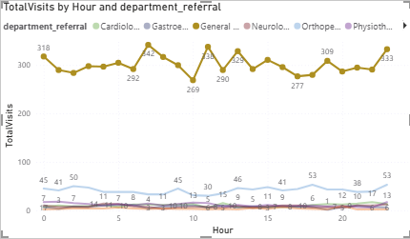
Insights:
  - Peak Hours: Strong patient inflow at 6 AM (342 visits), 11 AM (338 visits), and 1 PM (329 visits).
  - Low Hours: Noticeably fewer visits at 10 AM (269 visits) and between 5 PM–8 PM (277–300 visits).
  - The pattern reveals two busy periods — one in the morning and another around midday.
  - Early morning and mid-afternoon dips suggest natural transition windows for shift handovers.
Recommendation:
- Shift 1 (Morning Shift: 6 AM – 2 PM)
  - Covers early and mid-morning peaks (6 AM, 11 AM).
  - Ensure higher doctor availability during these hours.
- Shift 2 (Afternoon–Evening Shift: 2 PM – 10 PM)
  - Covers midday and evening consultations.
  - Balances workload after peak hours.
- Doctor Allocation Strategy
  - Assign more doctors in Shift 1 due to heavier patient load.
  - Keep fewer doctors in Shift 2, with backup/on-call support for occasional evening spikes.
Impact of Two-Shift Policy:
- Ensures adequate doctor coverage during peak demand.
- Reduces doctor fatigue by distributing workload evenly.
- Improves patient wait times and overall satisfaction.
Q12.What do you understand by PowerBI gateway? What are its use cases?
Ans.
- Definition: A software component installed on a local server that acts as a mediator between on-premises data and Microsoft cloud services.
- Purpose: Ensures secure, reliable, and efficient data transfer across environments.
- Types:
- Personal Gateway – for individual use, connects personal datasets to Power BI Service.
- Enterprise Gateway – for organizational use, supports multiple users and complex data sources.

Use Case | Description | Benefit
Automated Data Refresh | Keeps Power BI dashboards updated by syncing on-premises data with the cloud. | Eliminates manual uploads, ensures real-time insights.
Hybrid Data Connectivity | Connects cloud services with local databases (SQL Server, Oracle, SAP, Excel, SharePoint). | Enables organizations to leverage both on-prem and cloud data seamlessly.
Secure Data Transfer | Uses encryption and authentication to protect sensitive data during transfer. | Maintains compliance and data security standards.
Cross-Platform Integration | Works with Power BI, Power Automate, PowerApps, and Azure services. | Expands analytics and automation capabilities across Microsoft ecosystem.
Scalable Enterprise Reporting | Supports multiple users, large datasets, and complex queries. | Ensures enterprise-level performance and collaboration.

Challenge and Consideration:
- Installation & Maintenance: Requires proper setup and ongoing monitoring.
- Performance Bottlenecks: Poor configuration can slow down refresh cycles.
- Security Compliance: Must align with organizational IT policies and firewalls.
- User Training: Staff need awareness of gateway usage for effective adoption.

Summary:
Power BI Gateway is essential for organizations that rely on on-premises data but want the flexibility of cloud analytics. It ensures secure, automated, and scalable connectivity, making it a cornerstone for hybrid data strategies.
Q13.How would you approach this problem, if the objective and subjective questions weren't given?
Ans. Approach
In the absence of ready-made objective or subjective questions, my strategy would center on exploring the datasets comprehensively to uncover meaningful patterns, relationships, and insights that can guide hospital operations and decision-making.
Dataset Understanding:
- Initial Review: Examine the available tables (doctor_patients_data and hospital_er) to understand their structure, columns, and data types.
- Data Profiling: Perform profiling to detect missing values, inconsistencies, and distribution trends for key fields such as patient age, gender, race, satisfaction score, doctor name, and department referral. This step ensures data quality and readiness for analysis.
Key Analysis:
- Patient Demographics: Assess how age groups and genders influence visit frequency, satisfaction, and wait times.
- Department Insights: Evaluate patient load, satisfaction, and performance across departments to identify high- and low-performing areas.
- Doctor Evaluation: Track individual doctor performance using metrics like satisfaction scores, visit counts, and revenue contribution.
- Time-Based Trends: Study daily, weekly, and monthly patterns in visits and satisfaction to understand demand cycles.
Metrics & KPI:
- Wait Time vs. Satisfaction: Test whether longer wait times correlate with lower satisfaction.
- Revenue Analysis: Compare revenue across departments and doctors to identify profitability drivers.
- Patient Diversity: Measure demographic diversity within each doctor’s patient group.
- Performance Trends: Benchmark satisfaction scores across doctors and departments to highlight best practices.

Visualisation:
To make findings clear and actionable, I would use:
- Line Charts → Time-based trends.
- Bar/Column Charts → Department or demographic comparisons.
- Scatter Plots → Correlations (e.g., wait time vs. satisfaction).
- KPI Cards & Gauges → Key metrics such as average satisfaction score and total revenue.
Insights & Recommendation:
From the visual analysis, actionable insights would be extracted, such as:
- If longer wait times reduce satisfaction → recommend optimizing appointment scheduling.
- If certain doctors or departments underperform → suggest targeted training or improved resource allocation.
Reporting & Finding:
Finally, compile results and recommendations into a clear, structured report, aligning insights with hospital goals:
- Enhance patient satisfaction.
- Optimize resource utilization.
- Boost overall revenue.
Q14.Can you analyze and write the type of relationship between the doctor id and department, is it one-to-one?
Ans. Approach
- A DAX summary table was created to evaluate how many unique departments each doctor is associated with.
- This allowed identification of whether doctors are tied exclusively to one department or span across multiple.
Dr.RelationWithDepartment =
SUMMARIZE(
'Sheet1',
Sheet1[Doctor Name],
"TotalNoOfDepartments", DISTINCTCOUNT(Sheet1[department_referral])
)

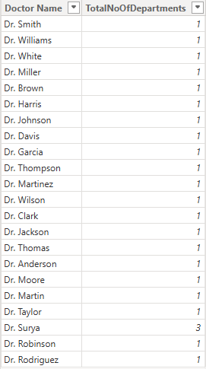
Insights
- The visualization shows that most doctors are linked to only one department, reflecting a standard one-to-one assignment.
- Dr. Surya is the sole exception, being associated with three departments, which suggests a cross-department role or shared specialization.
- All other doctors maintain a 1:1 relationship with their respective departments.
Conclusion
- The overall pattern indicates a one-to-one relationship between Doctor ID and Department.
- The exception of Dr. Surya introduces a one-to-many relationship, highlighting involvement in multiple specialties.
- This mixed structure suggests that while the hospital generally assigns doctors to a single department, some doctors may be strategically deployed across multiple areas to balance workloads or share expertise.

